A000-Asia-Mohenjo Daro-Mother Goddess Figure-Pannier Headdress-Terra cotta-2700-2100 BCE

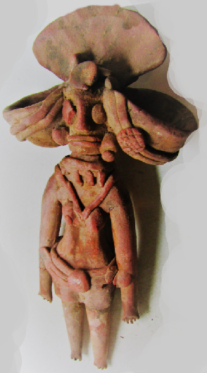 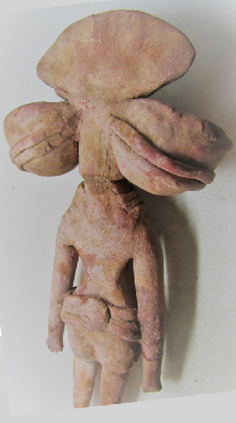

Asia-Mohenjo Daro-Mother Goddess Figure-Terra cotta-2700-2100 BCE Place of Origin: Mohenjo-Daro  
Materials: Terracotta

**Case no.: 3**

**Accession Number:**

**Formal Label:**

**Display Description:**

This terracotta Mother Goddess was, perhaps, a votive image for the earth and all her bounties indicated by her pannier headdress which was probably designed to hold fruits of the first harvest. This aspect Mother Goddess worship was also coupled with a fertility cult that seems to have been deep-rooted in India's soil. A large number of Mother Goddess figurines has been recovered from almost every excavated site, which suggests this dual theme of reverence for earth’s bounty and the aspects of promoting her fertility in the broadest sense was very wide-spread in the Indus Civiliztion. This figurine has been cast with an elaborate headgear supported by a pair of bands and a brooch, tight-fitted short tunic with skirt partly fastened with a broad waist-band using a medallion-like clasp, and tight-fitting trousers, with numerous embellishments such as necklaces and ear-ornaments.

This large size figurine from Mohenjo-Daro is an excellent example of the technical maturity that Harappan artisans had acquired in clay modeling and baking. The coating of thick red slip seems to have been applied not to just add luster or finish but perhaps also for protecting its surface from erosion. The fan-shaped headdress is like two large panniers, which hang on either side might have been conceived like fruit containers, oil-lamps or incense-trays. The figure of the Mother Goddess has been adorned with two necklaces: the smaller one has a set of four cylindrical pendants, while the longer one hangs between the breasts. Two circular pellets of clay form the eyes, the symbols of the awakened meditative soul which encourages th viewer to also engage in the meditation on earth’s bounties.

**LC Classification: DS392.2 M6**

**Date or Time Horizon:** 2700-2100 BCE

**Geographical Area:** Mohenjo-Daro

**Map:**

**GPS coordinates:**

**Cultural Affiliation:**

**Media:**

**Dimensions:**

**Weight:**

**Condition:**

**Provenance:**

**Discussion:**

**References:**

Dales, G., Kenoyer, J.M. and Alcock, L., 1986. *Excavations at Mohenjo Daro, Pakistan: The Pottery, with an Account of the Pottery from the 1950 Excavations of Sir Mortimer Wheeler* (Vol. 1). UPenn Museum of Archaeology.

**Appendix:**

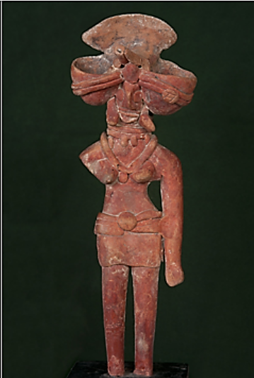

Dimensions: 23 x 8.5 cm  
National Museum, Nw Delhi, Acc. No. D.K. 3506/260

Place of Origin: Mohenjo-Daro  
Materials: Terracotta